Bahria University,

Karachi Campus



LAB EXPERIMENT NO.

**3**

LIST OF TASKS

|  |  |
| --- | --- |
| **TASK NO** | **OBJECTIVE** |
| 1 | Perform all the commands provided in the lab manual |
| 2 | Create an empty file with a .txt extension. Write a shell script that would write the current date, student’s name and registration number into that file, while using variables for all three entries. |
| 3 | Create a .txt file and input ten lines of entry while mixing it with both alphanumeric characters. Sort the contents of the created file in an ascending order and write the sorted output into another file. |
| 4 | Write C language programs that would generate the following for a given number $x$, e.g. $x=30$: Calculate the factorial of $x$. |
| 5 | write a Program to Sum of Natural Numbers Using for Loop |

Submitted On:

____________

(Date: DD/MM/YY)

**Task 1: Perform all the commands provided in the lab manual.**

**Solution:**

1. **Find Command:**

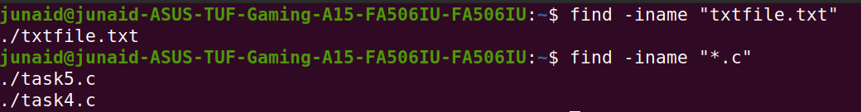

1. **Grep Command:**

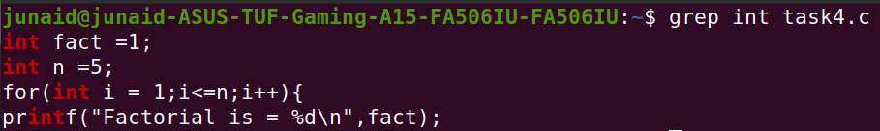

1. **Sort Command:**

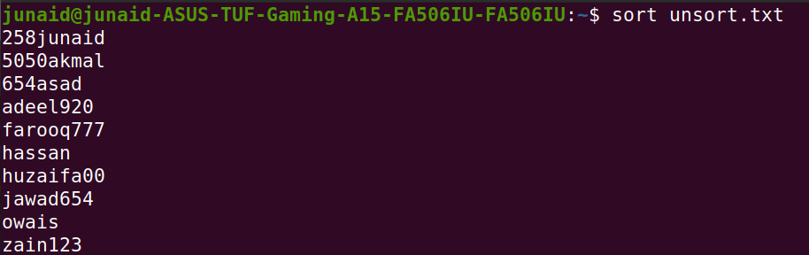

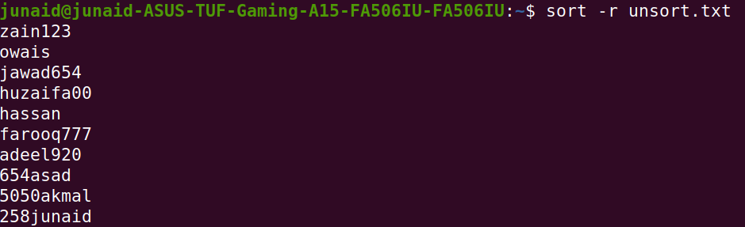

**Screenshot from 2022-04-04 07-24-37**

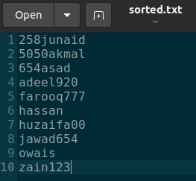

**Task 2: Create an empty file with a .txt extension. Write a shell script that would write the current date, student’s name and registration number into that file, while using variables for all three entries.**

**Solution:**

#!/bin/bash

read name

read reg

date > txtfile.txt

echo "$name" >> txtfile.txt

echo "$reg" >> txtfile.txt

**Output:**



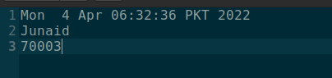

**Task 3: Create a .txt file and input ten lines of entry while mixing it with both alphanumeric characters. Sort the contents of the created file in an ascending order and write the sorted output into another file.**

**Solution:**

#!/bin/bash

echo "Enter 10 Alphanumeric Character:"

read one

read two

read three

read four

read five

read six

read seven

read eight

read nine

read ten

echo $one > unsort.txt

echo $two >> unsort.txt

echo $three >> unsort.txt

echo $four >> unsort.txt

echo $five >> unsort.txt

echo $six >> unsort.txt

echo $seven >> unsort.txt

echo $eight >> unsort.txt

echo $nine >> unsort.txt

echo $ten >> unsort.txt

sort unsort.txt > sorted.txt

**Output:**

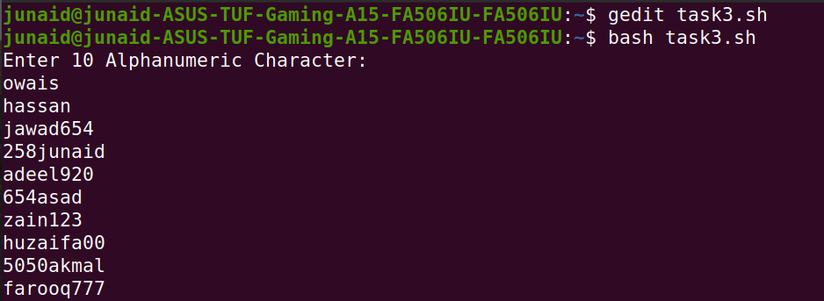

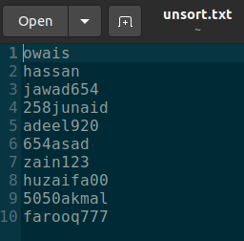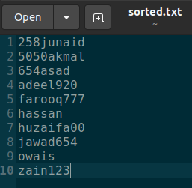

**Task 4: Write C language programs that would generate the following for a given number $x$, e.g. $x=30$: Calculate the factorial of $x$.**

**Solution:**

#include <stdio.h>

void main(){

int fact =1;

int n =5;

for(int i = 1;i<=n;i++){

fact *= i;

}

printf("Factorial is = %d\n",fact);

}

**Output:**

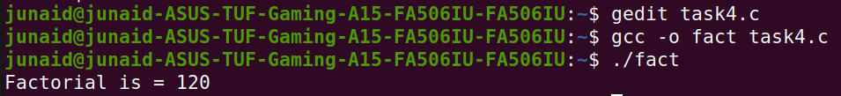

**Task 5: Write a Program to Sum of Natural Numbers Using for Loop.**

**Solution:**

#include<stdio.h>

void main(){

int sum = 0,n;

printf("Enter Range = ");

scanf("%d",&n);

for(int i = 1;i<=n;i++){

sum += i;

}

printf("The Sum is %d\n",sum);

}

**Output:**

